Experiment-2.1

**AIM-**

**CODE-**

public class notepad {

public static void main(String[] args) {

for(int i=0;i<args.length;i++) {

System.out.println(args[i]);

}

}

}

**OUTPUT-**

Experiment-2.2

**AIM-**

**CODE-**

import java.util.Scanner;

public class alphabetorder{

public static void main(String[] args) {

Scanner s=new Scanner(System.in);

System.out.print("Enter First Alphabet : ");

char c1=s.next().charAt(0);

System.out.print("Enter Second Alphabet : ");

char c2=s.next().charAt(0);

if(c1>c2) {

System.out.println(c2+","+c1);

}

else{

System.out.println(c1+","+c2);

}

}

}

**OUTPUT-**

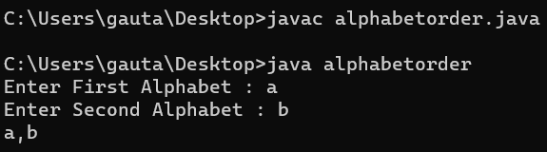

Experiment-2.3

**AIM-**

**CODE-**

import java.util.Scanner;

public class colorcode{

public static void main(String args[]) {

Scanner s = new Scanner(System.in);

System.out.print("Choice a Alphabet : ");

char choice = s.next().charAt(0);

switch (choice) {

case 'B':

System.out.println("Black");

break;

case 'W':

System.out.println("White");

break;

case 'R':

System.out.println("Red");

break;

case 'G':

System.out.println("Green");

break;

case 'Y':

System.out.println("Yellow");

break;

}

}

}

**OUTPUT-**

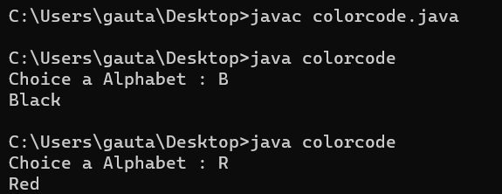

Experiment-2.4

**AIM-**

**CODE-**

public class evennum{

public static void main(String[] args){

for(int i =23; i<57;i++){

if(i%2==0){

System.out.println(i);

}

}

}

}

**OUTPUT-**

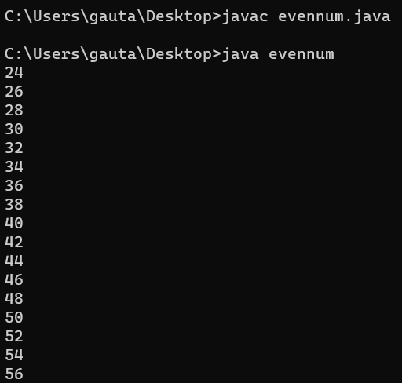

Experiment-2.5

**AIM-**

**CODE-**

import java.util.Scanner;

class palindrome {

public static void main(String args[]) {

int x, y=0,temp=0;

Scanner s=new Scanner(System.in);

System.out.println("Enter any number: ");

x=s.nextInt();y=x;

while(x>0){

temp =(temp*10) + (x%10);

x=x/10;

}

if(temp==y){

System.out.println("It is a Palindrome");

}else{

System.out.println("Not a Palindrome");

}

}

}

**OUTPUT-**

